**Java Development (Basic Level)**

My Travel cost (GUI Application)

Duration: 1 Day | Marks: 10

Mr. Ashfaq is running a transport company in Hyderabad and wants a desktop application that can help him to calculate cost of transport having following fields.

* Number of trucks (must be dropdown values 1 - 12).
* Item / category (must be dropdown having values (Electronics item, grocery items, woods, computer, others))
* Petrol cost per kilometer
* Total distance in KM
* Driver charges
* A button: when he clicks on button another screen for showing total cost per transfer and total bill in following format and have a print button also.

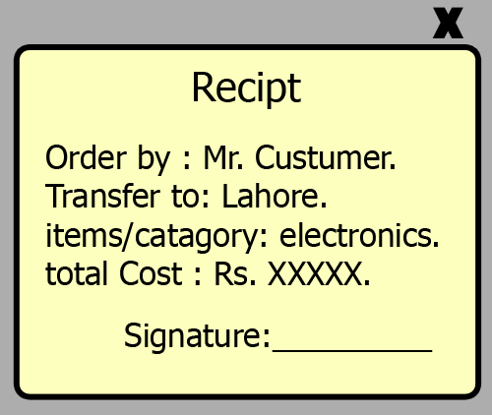

Assigned date: 30-05-2018

Submission date: 31-05-2018